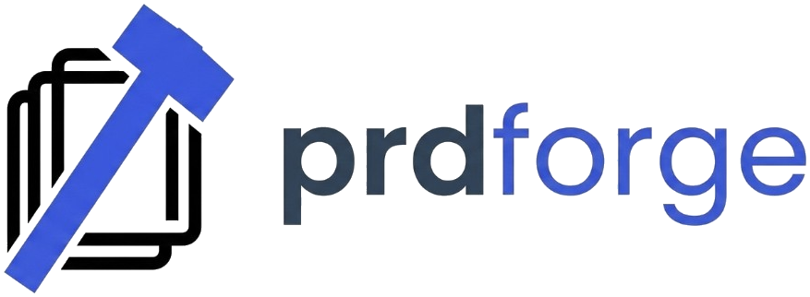

Product Brief (Starter)

1) Product Name
- Working name:

2) Problem Statement
- What problem are you solving?
- Who is affected most?
- Why now?

3) Target Users
- Primary user segment:
- Secondary segment:
- Current alternatives they use:

4) Core Value Proposition
- In one sentence:
- Top 3 user outcomes:

5) Success Metrics (First 90 days)
- Activation metric:
- Retention metric:
- Revenue or impact metric:

6) Scope

In Scope (v1)
-
-
-

Out of Scope (v1)
-
-
-

7) Constraints
- Budget:
- Team capacity:
- Compliance or legal:
- Timeline:

8) Risks and Assumptions
- Key assumptions:
- Top risks:
- Validation plan:

